**Chapter 4**

**Applications of Derivatives**

**4.6 Limits at Infinity and Asymptotes**

**Section Exercises**

**For the following exercises, examine the graphs. Identify where the vertical asymptotes are located.**

251.

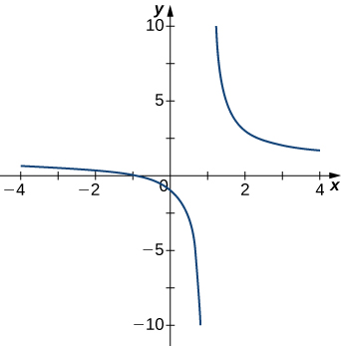

Answer:

253.

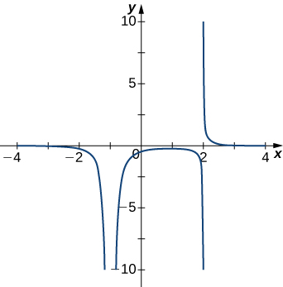

Answer: 

255.

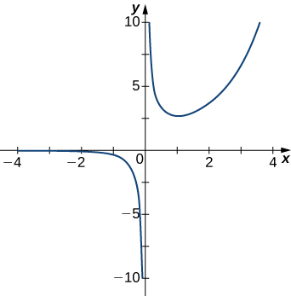

Answer:

**For the following functions, determine whether there is an asymptote at. Justify your answer without graphing on a calculator.**

257. 

Answer: Yes, there is a vertical asymptote

259. 

Answer: Yes, there is vertical asymptote

**For the following exercises, evaluate the limit.**

261. 

Answer: 

263. 

Answer: 

265. 

Answer:

267. 

Answer: 

269. 

Answer: 

**For the following exercises, find the horizontal and vertical asymptotes.**

271. 

Answer: Horizontal: none, vertical:

273. 

Answer: Horizontal: none, vertical: 

275. 

Answer: Horizontal: none, vertical: none

277. 

Answer: Horizontal: , vertical:

279. 

Answer: Horizontal:, vertical:and

281. 

Answer: Horizontal:, vertical:

283. 

Answer: Horizontal: none, vertical: none

**For the following exercises, construct a functionthat has the given asymptotes.**

285. and 

Answer: Answers will vary, for example:

287. , 

Answer: Answers will vary, for example: 

**For the following exercises, graph the function on a graphing calculator on the window and estimate the horizontal asymptote or limit. Then, calculate the actual horizontal asymptote or limit.**

289. **[T]** 

Answer: 

291. **[T]** 

Answer: 

293. **[T]** 

Answer: 

**For the following exercises, draw a graph of the functions without using a calculator. Be sure to notice all important features of the graph: local maxima and minima, inflection points, and asymptotic behavior.**

295. 

Answer:

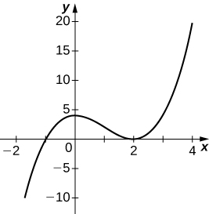

297. 

Answer:

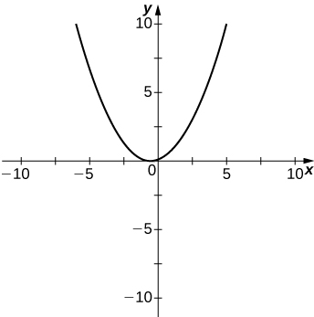

299. 

Answer:

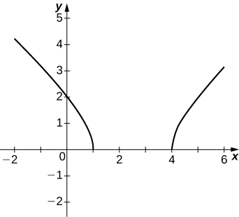

301. , on

Answer:

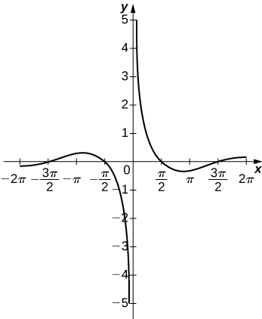

303. 

Answer:

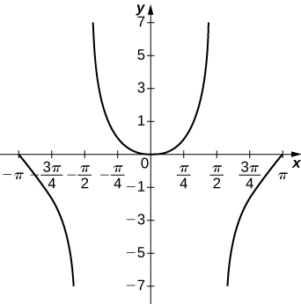

305. 

Answer:

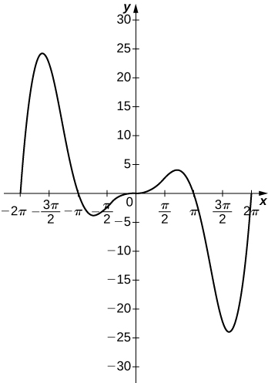

307. For  to have an asymptote at  then the polynomials  and  must have what relation?

Answer:  must have as a factor, where  has as a factor.

309. Both and have asymptotes at and  What is the most obvious difference between these two functions?

Answer:

This file is copyright 2016, Rice University. All Rights Reserved.